# Aflevering 2

Af Jesper Graungaard Bertelsen, AU-ID: au689481

Indholdsfortegnelse

Aflevering 2 1

Equations used 1

a. Drift currents 1

b. Width of depletion region in PN junctions. 1

c. Electric field along a pin structure 2

d. Built in potential due to depletion regions. 2

Opgave 1. Is the drift current formula limited to a homogeneous solid? 3

Opgave 2. Explain how the depletion region will vary with doping level in a p-n junction diode. 4

Opgave 3. A silicon sample is doped with doner impurities. 5

Opgave 4. A pin structure consists of an intrinsic region between the two doped regions as shown to the side: 7

a. Draw qualitatively the profiles of the electric field along the pin structure. 7

b. Sketch also the band diagram in equilibrium 8

c. Calculate the built‐in potential between both extremes of the pin structure. 9

## Equations used

### Drift currents

$$J=qNv_{d} <- Formula 3.32$$

$$J=q\sum_{i=1}^{N}{v_{i}} <- Formula 3.33$$

### Width of depletion region in PN junctions.

$$x_{p}=\sqrt{\frac{2ϵ_{s}}{e}·\frac{N_{d}}{N_{a}}·\frac{1}{N_{a}+N_{d}}} <- Formula 7.29$$

### Electric field along a pin structure

$$E=\int_{0}^{x_{p}}{-\frac{qN_{A}}{ϵ_{s}}dx}+\int_{x_{p}+d}^{x_{p}+d+x_{n}}{\frac{qN_{D}}{ϵ_{s}}dx} <-Formula 7.13$$

### Built in potential due to depletion regions.

$$V_{bi}=V_{T}\ln\left(\frac{N_{A}N_{D}}{n_{i}^{2}}\right) <-Formula 7.10$$

## Opgave 1. *Is the drift current formula limited to a homogeneous solid?*

As I see it, it depends. If we are talking about the

$$J=qNv_{d}$$

then that formula would suggest, that it is limited to homogenous solids, as N is the volume density of a material.   
Now one could find the average volume density, and then it might be right, but the other formula $$J=q\sum_{i=1}^{N}{v_{i}}$$ 
Does this alright too.   
======================================================================  
So my conclusion is, that the 1st formula is for the homogenous solids, while the 2nd, the summation formula is more practical for nonhomogeneous solids.   
======================================================================

## Opgave 2. Explain how the depletion region will vary with doping level in a p-n junction diode.

So how the variation of doping levels in a pn junction diode impacts the depletion region can be formulated by

$x_{p}=\sqrt{\frac{2ϵ_{s}}{e}·\frac{N_{d}}{N_{a}}·\frac{1}{N_{a}+N_{d}}}$ but can also be explained by intuition.   
From intuition we tell, that if the rate of increase in dopant of the holes is the same as the rate of increase for the electrons, then more atoms would go together to force in electrons. Here the increase in holes.   
We can then tell, that a flow would be more likely to happen, and as the depletion area is the barrier between the dopants, we can then by intuition tell, that this will be smaller, as the flow will be more likely. This is what we can interpret from the formula as well.

From the formula we see that and equal rate of increase in holes as equal rate in increase of electrons cancels out the 2nd term, but the width is also inversely proportional with the sum of the dopants seen in the 3rd term.

===========================================================================  
From our intuition we can tell, that an increase in dopants causes more electron affinity, which causes the depletion region barrier to be weaker compared to the forces of the current. Thereby making the barrier smaller.  
From the equation we tell the exact relationship, with a 3rd term telling us, that the increase of dopants does indeed decrease the width of the depletion barrier.   
===========================================================================

## Opgave 3. A silicon sample is doped with doner impurities.

Phosphorous, whose energy level is located $45meV$ below the conduction band. The concentration of impurity atoms is $N_{D}={10}^{15}cm^{-3}$

1. Discuss qualitatively the evolution of the Fermi level from 0K until high temperatures above 600K.

For this example, our semiconductor is negatively doped. n-type with more electrons in conduction band, than holes in valence band.   
It has $E_{D}=45meV$ and this will influence how the semiconductor acts.

*At around 0K*At 0K, all electrons will have occupied the lowest energy state ( The valence band ). This leads to a very bad hole concentration.   
As the silicon has been negatively doped, an amount of electrons may then sit at the donor level.   
Hole concentration ( Very bad ), electron concentration ( okay ) but not free. As the fermi level indicates the energy level due to both hole carriers and electron carriers, the fermi energy will then lay at about the donor level.

*At around 300K*At around 300K the electrons starts to be more likely to excite to higher energy states.   
Electrons from the doping level starts to excite to the conduction band, and then at higher thermal energy levels, the electrons from the valence band starts to excite.   
The donor concentration is still much higher than hole concentration, so the fermi energy level will still be higher than the intrinsic energy level, but little by little, the fermi energy level moves down, until…

*At around 600K*   
At around 600K the concentration of electron carriers and hole carriers are almost the same and persists that way for higher temperatures to come. The concentration of electron carriers is keeps being slightly higher, due to the doping the silicon had. It then goes to “equilibrium” at a higher concentration of donors than holes.

1. Sketch qualitatively the Fermi level position in such a wide temperature range.

A qualitatively sketch would look something like this:

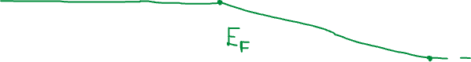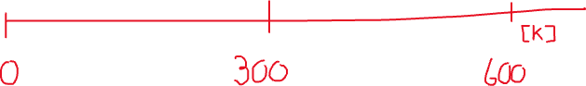

## Et billede, der indeholder diagram, linje/række, Teknisk tegning, Plan Automatisk genereret beskrivelseOpgave 4. A pin structure consists of an intrinsic region between the two doped regions as shown to the side:

In this question, both doped regions have the same concentration of impurities $(N_{A}= N_{D} = {10}^{15}cm^{-3})$.

The width of the intrinsic region is $d = 2µm$. The figure also shows the profile of the

charge density in the structure

### Draw qualitatively the profiles of the electric field along the pin structure.

This electric field along the pin structure can be described from poisson’s equation.

Our regions of non zero is, when starting at the depletion region of p. $$\left[0;x_{p}\right], \left[x_{p}+d;x_{p}+d+x_{n}\right]$$

$$ρ\left(x\right)=\left\{\begin{aligned}-qN_{a}, 0<x<x_{p} \\ +qN_{D}, x_{p}+d<x<x_{p}+d+x_{n}\end{aligned}\right\}$$

Which is the volume charge densities at a position x  
The electric field can be described as

$$E=\int_{D}{\frac{p\left(x\right)}{ϵ_{s}}dx}$$

*I haven’t been given a value for the $ϵ$ of the semiconductor. It might be possible to find a relation to it, in which I can describe it completely.*

It’s however just a constant, so this might not be necessary right now.

$$E=\int_{0}^{x_{p}}{-\frac{qN_{A}}{ϵ_{s}}dx}+\int_{x_{p}+d}^{x_{p}+d+x_{n}}{\frac{qN_{D}}{ϵ_{s}}dx}$$ Given that the charge e is constant, the permittivity is constant, and the doping concentration is constant:

$$E=-\frac{qN_{A}}{ϵ_{s}}\int_{0}^{x_{p}}{dx}+\frac{qN_{D}}{ϵ_{s}}\int_{x_{p}+d}^{x_{p}+d+x_{n}}{dx} \\ E=-\frac{qN_{A}}{ϵ_{s}}{\left[x\right]}_{0}^{x_{p}}+C_{1}+\frac{qN_{D}}{ϵ_{s}}{\left[x\right]}_{x_{p}+d}^{x_{p}+d+x_{n}}+C_{2}$$

$$E=\frac{qN_{A}}{ϵ_{s}}\left(-{\left[x\right]}_{0}^{x_{p}}+{\left[x\right]}_{x_{p}+d}^{x_{p}+d+x_{n}}\right), <-N_{A}=N_{D}, C_{1}+C_{2}=C=0$$

Its just two linear functions.

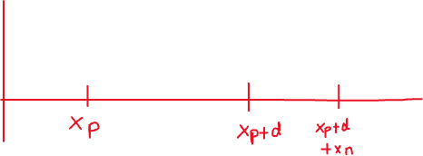

The triangles in the plot is just to   
tell the slopes.

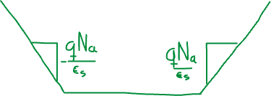

### Sketch also the band diagram in equilibrium

Taking inspiration from the Metal-semiconductor junctions, I will draw the band diagram.   
The metal is conducting always, thus the fermi energy level should be at the edge between the conduction band and valence band.

For equilibrium, the fermi energy should match which doping is used. For n type it should be slightly closer to the conduction band and for p type it should be slightly closer to the valence band.

Figure 1: Band diagram for Metal -> ntype junction

Thus the band diagram for the pin structure will look like:

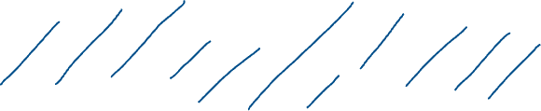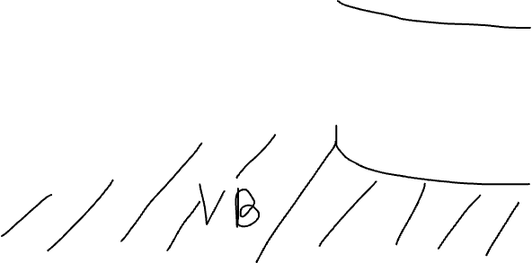

Note that this is a sketch, and the fermi energy levels might not be accurately placed.   
This is also under the assumption, that the intrinsic regions is a conductor.

### Calculate the built‐in potential between both extremes of the pin structure.

For this is know of a formula for built in potential: $$V_{bi}=V_{T}\ln\left(\frac{N_{A}N_{D}}{n_{i}^{2}}\right)$$  
I’ve been given $n_{i}={10}^{10}cm^{-3}$ $V_{T}=25mV$ $N_{A}=N_{D}={10}^{15}cm^{-3}$

$$V_{bi}=25mV·\ln\left(\frac{{10}^{30}}{{10}^{20}}\right)$$

$$V_{bi}=25mV·\ln\left({10}^{10}\right)≈0,5756463 V$$

So the build in voltages for both depletion regions is:   
=============== $V_{bi}=0,5756463 V$ 
   
===============